Multi Level Indexes

The indexing described so far involve ordered index files. A binary search is applied to the index to locate pointers to disk blocks or records in the file having a specific index field value.

Remember from before, a binary search requires log₂b_{i} block accesses for an index with b_{i} blocks. Each step of the binary search reduces the part of the index file we search by a factor of 2. (Each step divides the search space by 2, or halves the search space)

With multilevel indexes, the idea is to reduce the part of the index that we continue to search by a larger factor, the blocking factor of the index, where the bfr_{i} is greater than 2. The blocking factor of the index, bfr_{i} is called the fan-out, or fo of the multilevel index.

Searching a multilevel index requires approximately (log_{fo}b_{i}) block accesses which is a smaller number than for a binary search if the fan-out is larger than 2. If the fan out is equal to 2, there is no difference in the number of block accesses.

The index file is called the first level of a multilevel index. It is an ordered file with a distinct value for each key value K(i). Therefore we can create a primary index for the first level. This index to the first level is called the second level of the multilevel index.

The second level is a primary index, therefore we can use block anchors, and the second level has one entry for each block in the first level index. The blocking factor for all other levels is the same as for the first level, because the size of each index entry is the same. Each entry has one field value, and one block address.

If the first level has r₁ entries, and the blocking factor (which is also the fan out) for the index is bfr_{i} = fo, then the first level needs ⎡r₁/fo⎤ blocks, which is therefore the number of entries r₂ needed at the second level of the index.

If necessary, this process can be repeated at the second level. The third level, which is an index for the second level, has an entry for each second level block, so the number of third level entries is r₃ = ⎡r₂/fo⎤.

We only require a second level only if the first level needs more than one block of disk storage, and we require a third level only if the second level requires more than one block as well.

This process can be repeated until all the index entries at some level t fit in a single block.

The block at the t^{th} level is the top-level index. Each level reduces the number of entries from the previous level by a factor of fo (the index fan out or blocking factor of the index).

A multilevel index with r1 first level entries will have approximately t levels, where:
t = ⎡log_{fo}(r₁)⎤.

The multilevel indexes can be used on any type of index, primary, clustering, or secondary, as long as the first level index has distinct values for K(i), and fixed length entries.

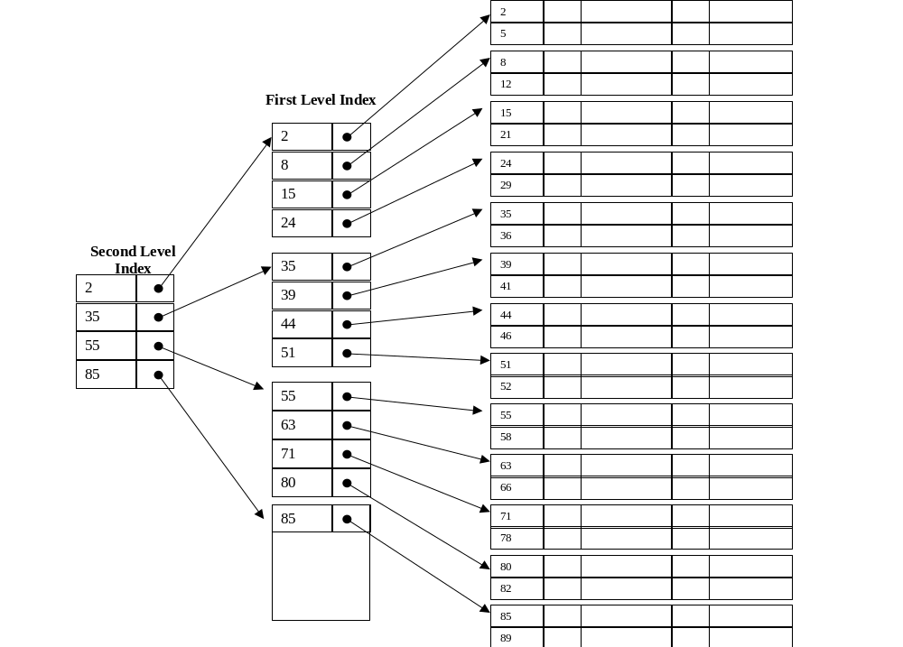Example of a two level Primary Index:

Example Question from Text:

Assume the dense secondary index from example 2 is converted into a multilevel index. The index blocking factor is bfr_{i} = 68 index entries per block. This value is also the fan out for the multilevel index. The number of first level blocks, b₁ was calculated as 442.
How many second level blocks?

b₂ = ⎡b₁/fo⎤ = ⎡442/68⎤ = 7 blocks.

How many third level blocks?

b₃ = ⎡b₂/fo⎤ = ⎡7/68⎤ = 1 block.

Because all of the index entries at the third level can fit into one block, the third level is the top level of the index, and t = 3. (Remember: t is the number of levels required)

To access a record by searching the multilevel index, we must access one block at each level, plus one block from the data file, so we need t + 1 = 3 + 1 = 4 block accesses. In example 2, using a single level index with a binary search, we required 10 block accesses.

In this example, a dense secondary index was used, meaning there was a index entry for each record in the table. You could also have a multilevel primary index which is non dense (for example if the first level is a primary index).

In this case, we must access the data block from the file before we can determine whether the record being searched for is in the file. With a dense index, this can be determined by accessing the first index level, without having to access the data file, since there is an entry in the index for each record in the file.

Using multi-level indexes, we can reduce the number of block accesses required to search for a record given its indexing field value. Insertions and deletions are still a problem because all the index levels are physically ordered files.

